David L. Suddjian
Biological Consulting Services

801 Monterey Avenue, Capitola, CA 95010
Telephone 831· 479· 9603, email dsuddjian@aol.com

Summary of 2005
Marbled Murrelet Monitoring Surveys

In The Santa Cruz Mountains

Prepared for

Command Oil Spill Trustee Council

Prepared by

David L. Suddjian
Biological Consulting Services
801 Monterey Ave., Capitola, CA 95010

September 2, 2005

INTRODUCTION

This report presents the results of Marbled Murrelet (Brachyramphus marmoratus, hereafter referred to as “murrelet”) monitoring surveys conducted in 2005 for the Command Oil Spill Trustee Council (COSTC) in the Santa Cruz Mountains at Big Basin Redwoods State Park, Portola Redwoods State Park, Butano State Park, and San Mateo County Memorial Park (Figure 1). These surveys were commissioned to assist the COSTC in restoration planning for potential projects benefiting the Marbled Murrelet.

Methods

Study Design

Dawn surveys were conducted at five stations in Big Basin, and at two stations each in Portola, Butano, and Memorial (Figure 1). Coverage at Butano, Memorial and one of the Portola stations was begun in 2003 to augment an existing long-term program of monitoring already established at Portola (since 1992) and Big Basin (since 1995). Since 2003 each station in each park has been surveyed three times annually from June to July, with two surveys at each in July. Two additional surveys are conducted at one of the Portola stations so that surveys occur there on three consecutive mornings in late June to continue a pattern of coverage begun at that station in 1992. Total annual surveys for each park are 15 at Big Basin, eight at Portola, and six each at Butano and Memorial.

Location of Survey Stations

Criteria for station placement and the selection of sites were described in Suddjian 2004.

The five stations at Big Basin (“Redwood Meadow”, “100 Acre Woods”, “Blooms Creek”, “Huckleberry #17”, and “Sempervirens”) were established in 1995 in a dispersed array in the upper watershed of the East Fork of Waddell Creek (Figure 2). “Redwood Meadow” station is at the meadow near the beginning of the Redwood Trail. “100 Acre Woods” station is on the North Escape Road at that road’s northern crossing of Opal Creek. “Blooms Creek” station is along East Ridge Trail east of Blooms Creek Campground. “Huckleberry #17” station is near site #17 in the tent cabins area of Huckleberry Campground. “Sempervirens” station is east of the Sempervirens Reservoir access road, midway between the reservoir and Lodge Road.

At Portola (Figure 3) the “Peters Creek Bridge” station at Portola (established in 1992) is located on the bridge adjacent to the park’s main campground. “Iverson” station (established in 2003) is located where Iverson Trail crosses Pescadero Creek west of park headquarters (Figure 3).

At Butano (Figure 4), “Ben Ries” station (established in 2003) is on the main park road 50 meters before the road enters Ben Ries Campground, adjacent to campsite #1. “Little Butano Creek” station (established in 2003) is at a large landslide along a park service road that begins at the entrance to the campground.

At Memorial (Figure 5), “Sequoia” station (established in 2003) is in the Sequoia Flat Campground where the main camp road enters the “D” section of the camp, adjacent to campsite #D1. “Memorial” station (established in 2003) is at Pescadero Creek adjacent to the Tan Oak Flat Picnic Area, at the site of the “swimming pool” that was formerly created seasonally in the creek.

Dawn Murrelet Surveys

Dawn murrelet surveys followed the standard protocol for audio-visual surveys in forests (Pacific Seabird Group 2003). David Suddjian conducted all the surveys. In addition to the murrelet survey data, all bird species detected (noting initial time, estimates of numbers, and other pertinent information) were recorded, and two unlimited distance point counts were conducted during each dawn survey (Appendix 1). The point counts lasted 10 minutes and began at 0-5 minutes and 45 minutes after sunrise. Additional details of observations of Common Ravens (Corvus corax) and raptors (direction, distance, behavior, etc.), and a best estimate of the maximum number of Steller’s Jays (Cyanocitta stelleri) noted during each survey were also recorded.

Seasonal Timing of Coverage

Survey dates for each park in 2005 are given on Table 1. An effort was made to schedule coverage at each station on dates close to when surveys were conducted there in previous years.

Additional Information on Murrelet Occurrence at Big Basin

Appendix 2 presents a summary of survey results from the Redwood Meadow / Park Headquarters parking lot of Big Basin. A total of 167 surveys following the same methods as those of this study have been completed at this site since 1991, representing the longest unbroken series of data for murrelets from any site in the Santa Cruz Mountains, and offering an opportunity to examine longer-term trends. In 2005 Suddjian conducted 13 surveys at the Redwood Meadow / Park Headquarters parking lot area from April 15 to July 24 in addition to the three for the COSTC contract.

Appendix 3 presents a summary of results from a USGS Breeding Bird Survey (BBS) route sampled by Suddjian from 1992 to 2005 that begins at Big Basin. While the BBS method is not specifically designed for monitoring murrelets at forest sites, it does provide a repeated measure of activity, and coverage for the BBS at Big Basin was contemporaneous with the other monitoring efforts presented in this report.

Results

Marbled Murrelet

Dawn flight activity in 2005 is characterized below for each park. Subjective descriptors of “low, “moderate,” and “high” activity refer generally to total detection counts in the range of 0-10 detections, 11-50 detections, and >50 detections, respectively. Results of the 2005 murrelet surveys are shown on Table 1. Tables 2 and 3 compare annual average activity at station.

Big Basin Redwoods State Park

Activity in 2005 remained very low compared to the park’s known history of high activity, but continued the pattern of the most recent years (Suddjian 2003a, 2003b, 2004, and 2005). Total detections and detections of “occupied site behavior” (i.e., below canopy flights) were both very low in 2005, with the 15 surveys yielding just 60 total detections and only four detections of below canopy flights; these were the lowest activity levels yet recorded for the park. Seven surveys (47%) had no detections at all. Low incidence of nesting was suggested by low frequencies of detections before sunrise (even on clear mornings) and of below canopy flights. There was no seasonal peak in flight activity, as could be expected in July. There were no observations of particular behavioral interest from any of the Big Basin surveys in 2005 (but see below for a report of eggshell fragments).

Even though flight activity is much reduced from levels before 2002, the area around “Redwood Meadow” remains a general hub for murrelet flight activity in the East Fork Waddell watershed. Surveys at “Redwood Meadow” this year produced 70% of all Big Basin detections recorded in 2005, and all four of the below canopy detections. Activity levels ranged from low to moderate (10-21 detections), with just one and three detections of below canopy flights on two of the three surveys (Table 1). A majority of detections were oriented toward the north, northwest and west of the meadow.

Activity at “100 Acre Woods” was very low (0-3 detections), with activity recorded on only the third survey and no detections of below canopy flights (Table 1). The three detections on July 21 involved murrelets flying up and down the Opal Creek drainage, and circling within 300 meters of the station.

Activity at “Huckleberry #17” was very low (0-3 detections; Table 1). The three detections on July 5 involved birds flying up the Sempervirens/Union Creek drainage, and circling back near or downstream of the station. None were seen below canopy, but in one of the detections a group of four murrelets flying at 1.4 canopy height were seen as they began a steep dive (with a “jet sound”) that may have taken them below the top of the forest canopy, but the rest of the dive was out of view.

Activity at “Blooms Creek” was low (1-7 detections), with no detections of below canopy flights (Table 1). All of the 12 total detections were oriented to the west, northwest or north and involved birds moving up the Blooms Creek drainage and then returning back down. Murrelets came upstream within 100 meters of the station on only three detections. No occupied site detections have been recorded at “Blooms Creek” since early July 2001.

“Sempervirens” had no detections on any of the surveys (Table 1). There have been no detections on any of the 12 surveys at “Sempervirens” since activity was last noted there in late July 2001.

Trends at Big Basin

Activity levels have remained relatively very low since 2002, following a major drop in activity from levels of the mid-1990s (Table 2; Figure 6). The long-term decline was significant for total detections (r² = 0.891, p = 0.0002) and occupied site detections (r² = 0.820, p = 0.0010) (Figures 6 and 7). Each station individually exhibited the same general pattern of a decline from relative high activity in the beginning years of monitoring to relative low activity in recent years (Figure 8). Data collected in 2005 from the more extensive series of surveys at Redwood Meadow (Appendix 2) and from the BBS route (Appendix 3) continued to match the pattern of decline documented by this study, and show continued incremental decreases over the last five years (Figure 2-4 in Appendix 2).

Nesting Evidence at Big Basin

Marbled Murrelet eggshell fragments were found on May 25, 2005 by park docent Scott Pedan on North Escape Road just north of the road’s southern crossing over Opal Creek (Figure 9). There was one fragment of about ¼ to ⅓ of the eggshell, and many tiny fragments that had been run over by a vehicle or trodden upon by hikers. Pedan photographed the fragments, and moved the larger one to a nearby spot off the road. The remains were not collected until over a week later, when the larger fragment had been disturbed and only much smaller bits were left. These were taken by David Suddjian and will be deposited at the Western Foundation of Vertebrate Zoology. The location of the nest was unknown, although several trees with suitable platforms are in the near vicinity of the site where the fragments were found. The nest’s outcome is also uncertain. This is apparently the only direct evidence of a nesting attempt in the Santa Cruz Mountains region for the 2005 season.

Portola Redwoods State Park

Activity at “Peters Creek Bridge” was moderate on the three consecutive surveys in late June (14-26 detections), but showed no increase on the two July surveys (11-18 detections; Table 1). Just a single detection of a below canopy flight was recorded from the five surveys, the only one (!) recorded on surveys in Portola in 2005. Activity around the station was less varied in direction than in most prior years, with a focus of activity to the northwest, north and northeast of the station.

Activity at “Iverson” was low on all three surveys (1-7 detections), with no detections of below canopy flights (Table 1). This low level of activity contrasted strongly with that noted in 2003 and 2004 (Suddjian 2004 and 2005), when activity at “Iverson” had consistently been among the highest of any station in this study (Table 2). In 2005 there were no detections of murrelets flying low over Pescadero Creek, and very few detections with extensive circling activity in the vicinity of the station.

There were no observations of particular behavioral interest during any of the Portola surveys in 2005. The expected July peak in activity was not evident on the Portola surveys.

Trends at Portola

Three Consecutive Mornings at Peters Creek Bridge. The only long term comparison available for Portola is for the surveys conducted on three consecutive mornings in late June at “Peters Creek Bridge” (Table 3). Activity in 2005 was the lowest yet recorded for that effort, both for total detections and occupied site detections, but was only marginally lower than activity in 2003 and 2004 (Table 3, Figure 10). Linear regression on average total detections over the whole period of 1992-2005 showed a significant declining trend (r² = 0.353, p = 0.04; Figure 11). The declining trend for occupied site detections was non-significant over the whole period of 1992-2005 (p = 0.24), but was significant from 1995 onwards (r² = 0.652, p = 0.014).

Entire Season. Average detections from Portola stations over the entire survey season were down dramatically in 2005 from 2003 and 2004 for both total detections (Figure 12) and occupied site detections (Figure 13). The three year period showed a highly significant decline in occupied site detections (r² = 0.992, p = 0.029). The sharp decrease at both stations, but especially “Iverson” station is shown on Figure 14.

Butano State Park

Activity at “Ben Ries” ranged from low to moderate (4-27 detections), with no below canopy flights recorded (Table 1). As in 2003 and 2004 (Suddjian 2004 and 2005), activity was oriented toward Little Butano Creek or up the canyon to the east, and included detections of birds moving up or down the drainage. Flight activity over the adjacent campground was infrequent in 2005.

Activity at “Little Butano Creek” was moderate (24-29 detections), with 1-10 occupied site detections noted on two of the three surveys (Table 1). Activity at this station averaged the highest for any station in the study in 2005. As in 2002 and 2003 (Suddjian 2004 and 2005), each survey recorded extensive movement by murrelets flying up and down the drainage, and circling over the canyon in the vicinity of the station. The 10 below canopy flights on June 14 was the highest number of occupied site detections observed on any survey this year.

There were no observations of particular behavioral interest during any of the Butano surveys in 2005. The expected July peak in activity was not strongly evident on the Butano surveys, except for a minor increase in early July at “Ben Reis” station (Table 1).

Trends at Butano

Average detections from Butano stations were down dramatically in 2005 from 2004, but were only marginally lower than 2003 (Figures 12, 13 and 14). The change from 2004 to 2005 at Butano was the greatest for any of the four parks this year. The three year trend showed a shallow, non-significant decline for both total detections and occupied site detections.

San Mateo County Memorial Park

“Memorial” had very low activity (0-3 detections), and no detections of occupied site behavior (Table 1). The three detections on July 9 were of birds circling in the distance or flying high over Pescadero Creek. The single detection on July 27 was of a single distant “keer” call. After three years of surveys here there has been little indication that murrelets use the Pescadero Creek corridor as a flyway at this station. “Memorial” remains the only station in this study to never have an occupied site detection on any survey (n = 9).

“Sequoia” had no detections on the June survey, but moderate activity (16-30 detections) on the two July surveys; no below canopy flights were observed in 2005 (Table 1). Most (80%) of the detections were more than 100 meters away from the station, and 95% were oriented to the west, southwest or northwest. Some involved murrelets apparently flying over Pescadero Creek west of the station, or circling (sometimes extensively) west of the station. Interestingly, the forest west of the Sequoia Flat Campground, where activity was centered, is mostly relatively poor nesting habitat for murrelets. The 30 detections on July 26 was the highest tally for any survey in 2005.

There were no observations of particular behavioral interest during any of the Memorial surveys in 2005. The expected July peak in activity was evident at “Sequoia” station, the only station to clearly exhibit this pattern in 2005.

Trends at Memorial

Memorial was the only park with an increase in detections in 2005, although it was very slight (Figure 12), and did not include an increase in occupied site detections (Figure 13). The three year trend shows a shallow, non-significant increase for total detections and a shallow non-significant decline for occupied site detections.

CORVIDS

Counts of Steller’s Jay and Common Raven from the dawn surveys at each station are given on Table 4. General summaries of numbers and activities around the murrelet survey station are given below. Observations related to corvid management efforts begun in 2005 will be addressed in the report on the 2005 corvid surveys.

Big Basin Redwoods State Park

Steller’s Jay

Steller’s Jay was detected at all stations and on nearly all surveys; none were noted on the June 21 survey at “100 Acre Woods” and it was only heard there after the survey on July 21. The pattern of relative abundance among stations closely matched that of prior years (Suddjian 2003a, 2004, 2005a), with highest abundance correlated with the proximity to campgrounds (Table 4). Overall jay abundance recorded during the murrelet surveys decreased from 2004, but was within the range of that observed in 2001-2004 (Figure 15). The only marked change in jay numbers compared to prior years was a decrease at “Huckleberry 17” (the site with the most jays), where the peak of 17 recorded during the 2005 murrelet surveys was lower than on any prior year, but only marginally lower than the peak of 19 in 2003.

Common Raven

Common Raven was detected at all stations and on nearly every survey (it was missed on two of the three surveys at “Sempervirens”). Counts ranged from 1-5 per station (Table 4). Raven abundance recorded during the murrelet surveys decreased only slightly from 2004, but was within the range of that observed in 2001-2004 (Figure 15). Territorial pairs and/or singles resided near each of the stations, but productivity was notably low; only two sets of fledged young were observed for certain in the study area in 2005, and fledging occurred later than average.

“Redwood Meadow” had a pair of adults roosting to the west of the station on each survey, and they ranged in that area and over towards the park store and Highway 236, and apparently did not produce young in 2005. Another pair was north of the meadow at the south end of Opal Creek Picnic Area. The latter pair had two newly fledged juveniles by July 17. One to three additional “single” ravens were noted on the surveys at “Redwood Meadow.” Only a single adult raven was noted on each survey at “100 Acre Woods”, noted to varied directions each date, and with limited activity evident from the station. At “Blooms” Creek” numbers of ravens detected during the surveys increased from one in mid-June to four in late July (all adults), but most detections were of birds that roosted to the northeast and east of the station. At “Huckleberry #17” one pair of adults focused its activities at the tent cabins area. This pair may have had an active nest just south of the camp hose site on June 20 (same location as in 2004), but if so it had apparently failed by early July. Another pair of adults at the northwest end of Huckleberry Campground fledged three young by July 19. One or two additional “singles” may also been noted at “Huckleberry #17” during the dawn surveys. The only ravens noted at “Sempervirens” during the murrelet surveys were a pair toward Sempervirens Reservoir on the late July survey.

No exceptional concentrations were noted in the study area proper, but observations in early June along China Grade in the upper Sempervirens Creek watershed suggested a small roost of non-breeding adults was located in that area (Suddjian pers. obs.).

Portola Redwoods State Park

Steller’s Jay

Steller’s Jay was detected on all surveys at both stations, with somewhat more tallied at “Peters Creek Bridge” (at the edge of the campground) than at “Iverson” (Table 4). Overall jay abundance recorded during the murrelet surveys decreased slightly from 2004, but was within the range of that observed in 2003-2004 (Figure 15). Portola had the lowest jay abundance of the four parks.

Common Raven

A single adult Common Raven was noted on just two of five surveys at “Peter’s Creek Bridge” and none were recorded on the three surveys at “Iverson” (Table 4), a marked decrease in abundance compared to 2003-2004 (Figure 15). Only one pair of ravens was confirmed to be present in the general region of park encompassed by the main campground, group camps, headquarters area, main service road and Iverson Trail. This pair, whose members were most often seen singly, was sometimes joined by a third adult. On the whole they were relatively quiet and spent little time at the main campground. No evidence suggested successful nesting during extensive field time on June 26-30, July 11-13, and July 27-28. Then on July 29 a family group of two adults and three juveniles was seen flying low over the forest over the main park road about 0.5 mi. north of park headquarters. This family may have been from the local pair, but were more likely moving from a nest site outside of the general area outlined above in this paragraph.

Flocks of “non-local” ravens were seen dawn during surveys in 2002 and 2003 “commuting” from a roost site (Suddjian 2003a, 2003b, 2004), but no flocks were seen in 2004. In 2005 the only similar observation was of seven adults flying north past the north end of Upper Coyote Ridge Trail in Pescadero Creek County Park at 9:30 a.m., about 1.9 miles north of the Portola park headquarters.

Butano State Park

Steller’s Jay

Steller’s Jay was detected on all surveys at both stations, with more jays recorded at “Ben Ries” (beside the campground) than at “Little Butano Creek” (Table 4). Overall jay abundance recorded during the murrelet surveys decreased slightly from 2004, but was within the range of that observed in 2003-2004 (Figure 15).

Common Raven

Single Common Ravens were evident on each survey at “Ben Ries”, but none were noted during any survey at “Little Butano Creek” (Table 4). However, shortly after the conclusion of the July 22 survey a family with at least two recent fledglings was noted downstream of “Little Butano Creek” station (north of the north end of Goat Hill Trail). This family was likely offspring of the raven noted at “Ben Ries” during the surveys and of the pair noted at the campground at other times outside the 2-hour dawn surveys. Overall raven abundance decreased notably on the dawn surveys from 2004 (Figure 15). There was probably only one pair in the central part of the park in 2005, but at least two other family groups were noted elsewhere in the park.

San Mateo County Memorial Park

Steller’s Jay

Steller’s Jay was detected on all surveys at both stations, but as in past years they were much more numerous at “Sequoia,” within the large Sequoia Flat Campground, than at “Memorial” (Table 4). Jays were more abundant at Memorial County Park than the other parks, and abundance as recorded during the dawn surveys has increased somewhat each year since 2003 (Figure 15).

Common Raven

Common Ravens were encountered regularly at both stations, and families with juveniles were noted at “Sequoia” (Table 4). Overall raven abundance decreased from 2004 (largely due to lower productivity), but was similar to that of 2003 (Figure 15). One pair nested at the west edge of the “B” section of Sequoia Flat Campground, fledging two juveniles by July 8. Another pair with two juveniles on July 26 at the south end of Sequoia Flat campground was from an unknown nesting location. A third pair frequented the east half of the park and was recorded from “Memorial” station, but this pair apparently did not produce young in 2005.

RAPTORS

Big Basin Redwoods State Park

An adult Sharp-shinned Hawk (Accipiter striatus) was observed flying past “Sempervirens” on July 17, and two begging juveniles were found about 250 meters south of the station after the survey. Elsewhere, an adult was along Highway 236 on May 25, and a family group of three juveniles was at the top of North Escape Road on July 6.

Adult Cooper’s Hawks (A. cooperi) were calling near “Sempervirens” on June 17, at “Huckleberry #17” on July 5 and 19, and at “Blooms Creek” on July 7 and 20. A silent adult was at Blooms Creek Campground on July 19.

Red-shouldered Hawk (Buteo lineatus) was noted on multiple dates in the vicinity of Opal Creek near “Redwood Meadow”. One was perched at Huckleberry Campground on June 20. A juvenile was at Wastahi Campground on July 5. An adult heard calling south of “100 Acre Woods” on July 6 was the first noted from that station, and the farthest upstream the species has been found in the Opal Creek watershed.

An adult male Peregrine Falcon (Falco peregrinus) flew south over Opal Creek at Redwood Meadow on June 18. The nest site near the East Fork of Waddell Creek that had been used in the 1990s was still inactive in 2005.

Western Screech-Owl (Megascops kennicottii), Northern Pygmy-Owl (Glaucidium gnoma), and Northern Saw-whet Owl (Aegolius acadicus) were heard in various places in the study area this year.

Portola Redwoods State Park

An adult Sharp-shinned Hawk was at “Peter’s Creek Bridge” on July 29 and near there on August 26. Elsewhere, one was at Slate Creek Trail Camp on June 29, and family groups of begging juveniles were in adjacent Pescadero Creek County Park at Bridge Trail on July 28 and at the headwaters of Hooker Creek on July 29.

An adult Cooper’s Hawk was at Point Group Camp near “Peters Creek Bridge” on July 12. Elsewhere, a family group of begging juveniles was in Pescadero Creek County Park along Old Haul Road near Rhododendron Creek on July 28.

One pair of Red-shouldered Hawks, noted on multiple dates, resided in the area between Park Headquarters and the east end of Coyote Ridge Trail, sometimes visiting the main campground. Two (perhaps the same) were heard from “Iverson” on July 12. Elsewhere, an adult was at the high point on Bear Creek Trail on June 29.

An adult Peregrine Falcon was perched on a snag on a high bank over Pescadero Creek about 300 meters south of “Peters Creek Bridge” on July 12.

Western Screech-Owl was heard occasionally in the study area this year, and a Barn Owl (Tyto alba) was noted at the main campground on July 12 and August 25.

Butano State Park

A family of two juvenile Sharp-shinned Hawks was near Little Butano Creek between “Ben Ries” and “Little Butano Creek” stations on July 22 and 25. Elsewhere, an adult was seen over the picnic area near the park entrance on June 15.

Adult Red-shouldered Hawks were in the vicinity of the campground and “Ben Ries” station on June 30, and July 22 and 25.

Barn Owl, Western Screech-Owl and Northern Pygmy-Owl were heard around the campground and “Ben Ries” station on multiple, including juvenile Barn Owls at the camp on July 21.

San Mateo County Memorial Park

An adult Sharp-shinned Hawk flew past “Sequoia” station on July 8, and a family of two begging juveniles were just south of Sequoia Flat Campground on July 26.

An adult Cooper’s Hawk was heard southwest of “Sequoia” station on July 8, and northwest of there on July 26. On the latter date it was subsequently seen taking a juvenile jay at the station.

Two territorial pairs of Red-shouldered Hawks were present at this park and surroundings in June and July, frequenting the vicinity of both stations on various dates.

A family group of four juvenile Peregrine Falcons flew from east to west over “Sequoia” station on July 8, apparently moving from a roost located east of the park. Subsequent correspondence with Loma Mar resident Jeneen Sommers (pers. comm.) revealed that she had heard this group of juveniles in the Loma Mar area on other dates in the week before July 8, and occasionally in the week after. On July 26 they were again spotted flying west over “Sequoia” station during the dawn survey. On that date they perched some distance west of the station, and vocalizations indicative of an adult delivering prey to the juveniles were heard. The nest site of these falcons is unknown, but the observation on both dates of the family flying from the east early in the morning suggests the site could be east of Memorial Park. The nearest known nest site is 2.75 miles south of Memorial Park at the South Fork of Butano Creek.

A Barn Owl was heard at Sequoia Flat Campground on June 15 and July 25, and a Western Screech-Owl was there on June 15.

Discussion

The 2005 breeding season had the lowest recorded inland flight activity by Marbled Murrelets in the history of this study, both for areas surveyed over the longer-term (Big Basin stations and “Peter’s Creek Bridge” at Portola), and for most areas with only three years of coverage (Butano stations and “Iverson” at Portola. Only data from Memorial was contrary to this pattern, but in a mixed way; while average activity increased somewhat at “Sequoia” it remained very low at “Memorial” and no occupied site detections were recorded in that park. When data are pooled from all four parks, activity in 2005 was down from the 2003-2004 average by 54% for total detections and by 88% for occupied site behaviors (Figure 16). Nearly all of the decrease evident in 2005 was due to marked declines in activity at Portola and Butano, the two parks with the most activity (Figures 12 and 13). Activity at Big Basin had already been low since 2002, and activity at Memorial (even though it increased somewhat in 2005), was relatively low compared to the Portola and Butano. Continued monitoring in the Gazos Creek watershed by S. Singer was apparently the only other monitoring occurring in the Santa Cruz Mountains in 2005, and Singer (pers. comm.) reported unusually low activity in that watershed, as well. Two other anecdotal reports fit this pattern. Long-term coastal resident G. Strachan (pers. comm..) reported that Marbled Murrelet flights to the ocean at dawn were the lowest ever over his residence near Año Nuevo through at least early July. Garth Harwood (pers. comm..), residing near Dearborn Creek in the Pescadero Creek watershed (two miles southwest from Memorial County Park), reported a general paucity of dawn flight activity until mid-July.

Some of the decrease in activity in 2005 no doubt resulted from poor foraging conditions that led to reduced levels of murrelet breeding effort and visitation of inland sites for other reasons (e.g., social interaction, courtship, scouting future nest sites). A lack of upwelling from winter to at least early summer 2005 led to the disappearance of oceanic plankton, impacting fisheries and leading to a seabird mortality event in winter and spring, and a widespread collapse of nesting effort and success for many seabirds (Nevins et al. 2005, Mendenhall 2005, W. Sydeman pers. comm., Suddjian pers. obs.). Substantial breeding failure or mortality was evident for common species such as Brandt’s (Phalacrocorax penicillatus), Pelagic (P. pelagicus) and Double-crested (P. auritus) cormorants, Common Murre (Uria aalge), Pigeon Guillemot (Cepphus columba), and Cassin’s (Ptychoramphus aleuticus) and Rhinoceros auklets (Cerorhinca monocerata). Although oceanographic conditions differed from those expected for an El Niño – Southern Oscillation (ENSO) event, the resulting impact on foraging resources for seabirds and their nesting success was apparently similar.

Evidence indicates that these oceanic conditions probably affected Marbled Murrelets, presumably reducing nesting effort, nesting success and visitation of breeding areas. The distribution of murrelets along the coast of the Santa Cruz Mountains from April to July was similar to that of ENSO years: reduced numbers in the core region from Pescadero Point to Waddell Creek (D. Suddjian pers. obs., R. Thorn pers. comm., P. Metropulos pers. comm.), and atypical numbers off the Santa Cruz area coast from Terrace Point to Seacliff (S. Gerow pers. obs., D. Suddjian pers. obs.). Some were noted along the Big Sur coast, such as at Andrew Molera State Park, from April into early July (Big Sur Ornithology Laboratory), an area where the species is only irregularly found in spring, and generally not into summer (Roberson 2002). The very low incidence of below canopy flights on the 2005 surveys, especially at stations where they had been much more frequent in 2003-2004 (Figures 13 and 16), was also indicative of low breeding effort. Birds flying below the forest canopy are those most likely to be engaged in active nesting in the vicinity of a survey station (Nelson 1997, Singer et al. 1995, Pacific Seabird Group 2003). Low breeding effort would also be expected to result in the observed reduction in flight activity before sunrise, the time in which nesting adults exchange incubation duty and most consistently visit their nest to feed their chick (Nelson 1997, Nelson and Hamer 1995). Lastly reduced visitation to inland sites by non-breeders might have resulted in the general lack of any seasonal peak in flight activity observed in 2005 (Nelson 1997).

Even if the reduction in murrelet activity at inland sites in 2005 was partially due to unfavorable ocean conditions, the decline also fit the long term downward trend for the two areas with longer-term data (Big Basin and “Peters Creek Bridge”), and some portion of the change in activity may also reflect continued declines in the regional population. An exceptionally poor nesting season in 2005 coupled with increased mortality could accelerate a population decline in the region.

In 2003 and 2004 murrelet activity was much greater at Portola and Butano than at Big Basin and Memorial, despite Big Basin’s considerably larger area of nesting habitat and historic high activity. The reduced activity at Portola and Butano in 2005 brought levels of activity in those parks much closer to that of Big Basin and Memorial (Figures 12 and 13). The reasons for higher relative activity at Portola and Butano remain unresolved and somewhat mysterious. It is tempting to link higher corvid populations at Big Basin and Memorial (Suddjian 2005b) with relatively low murrelet activity in those parks, but much of the available habitat at Big Basin is well removed from the high concentrations of corvids associated with that park’s areas of high use, and in 2005 activity recorded at “Sequoia” in Memorial was on a par with activity at Portola and Butano. It may be that some other factors sustain higher activity levels at Portola and Butano, even in the face of a declining regional population.

Acknowledgements

Supervising rangers Holly Huenemann (Portola), Gary Strachan (Butano), Mary Hazel (Big Basin), and other staff at all the parks provided essential logistical support that facilitated the murrelet surveys.

Literature Cited

Mendenhall, V. 2005. Widespread breeding failures and dieoffs of seabirds in the Northeast Pacific. Pacific Seabirds 32 (1): 27-28.

Nelson, S. K. 1997. Marbled Murrelet (Brachyramphus marmoratus). In The Birds of North America, No. 276 (A. Poole and F. Gill, eds.). The Academy of Natural Sciences, Philadelphia, PA, and The American Ornithologists’ Union, Washington, D.C.

Nelson, S. K. and T. E. Hamer. 1995. Nesting biology and behavior of the Marbled Murrelet. Pp. 57-67 in Ralph, C.J., Hunt G.L. Jr., Raphael, M. G. and Piatt, J.F. (tech. eds.). Ecology and conservation of the marbled murrelet. Gen. Tech. Rep. PSW-GTR-152. Albany, C: Pacific Southwest Research Station, Forest Service, U.S. Dept. of Agriculture; 420 p.

Nevins, H., Harvey, J. T., Miller, M., Jessup D., Lyday, S. and J. Roletto. 2005. Report on California seabird mortality event, January – May 2005. Unpubl. Report dated June 20, 2005. Moss Landing Marine Laboratories.

Pacific Seabird Group. 2003. Methods for surveying Marbled Murrelets in forests: a revised protocol for land management and research. Marbled Murrelet Technical Committee. Unpubl. report dated 6 January, 2003.

Paton, P. W. C. and C. J. Ralph. 1988. Geographic distribution of the marbled murrelet in California at inland sites during the 1988 breeding season. Unpubl. report, California Dept. of Fish and Game.

Paton, P. W. C. and C. J. Ralph. 1990. Distribution of the Marbled Murrelet at inland sites in California. Northwestern Naturalist 71:72-84.

Roberson, D. 2002. Monterey Birds. Monterey Peninsula Audubon Society. Carmel, CA.

Singer, S. M, D. L. Suddjian and S. A. Singer. 1995. Fledging behavior, flight patterns, and forest characteristics at Marbled Murrelet nests in California. Northwestern Naturalist 76:54-62.

Suddjian, D. L. 2001. 2001 Marbled Murrelet Monitoring Surveys at Big Basin and Portola State Parks. Unpubl. report. Prepared for the California Dept. of Fish and Game.

Suddjian, D. L. 2003a. Summary of 2002 Marbled Murrelet monitoring surveys
at Big Basin and Portola State Parks. Unpubl. report. Prepared for the California Dept. of Fish and Game.

Suddjian, D. L. 2003b. Summary of 2003 Department of Fish and Game Marbled Murrelet Monitoring Surveys At Big Basin and Portola Redwoods State Parks Unpubl. report prepared for the California Dept. of Fish and Game.

Suddjian, D. L. 2004. Summary of 2003 Marbled Murrelet Surveys in the Santa Cruz Mountains. Unpubl. report prepared for Command Oil Spill Trustee Council.

Suddjian, D. L. 2005a. Summary of 2004 Marbled Murrelet Surveys in the Santa Cruz Mountains. Unpubl. report prepared for Command Oil Spill Trustee Council.

Suddjian D. L. 2005b. Summary of 2004 Corvid Monitoring Surveys in the Santa Cruz Mountains. Unpubl. report prepared for Command Oil Spill Trustee Council.

Table 1. Summary of dawn murrelet surveys conducted at each park in 2005.

Station Date Obs. Cloud Precip. Total # OB¹
Cover # Dets. Dets.

Big Basin

Redwood Meadow 18 June 05 DLS 100% Brief shwr 21 0
Redwood Meadow 4 July 05 DLS 0% None 10 1
Redwood Meadow 18 July 05 DLS 0% None 11 3

100 Acre Woods 21 June 05 DLS 0-100% Fog 0 0
100 Acre Woods 6 July 05 DLS 0-100% Fog 0 0
100 Acre Woods 20 July 05 DLS 100% Brief shwr 3 0

Blooms Creek 22 June 05 DLS 0-100% Fog 1 0
Blooms Creek 7 July 05 DLS 0% None 4 0
Blooms Creek 20 July 05 DLS 0% None 7 0

Huckleberry #17 20 June 05 DLS 0% None 0 0
Huckleberry #17 5 July 05 DLS 100% Fog 3 0
Huckleberry #17 19 July 05 DLS 15-25% None 0 0

Sempervirens 17 June 05 DLS 100% Brief shwr 0 0
Sempervirens 3 July 05 DLS 0-100% Fog 0 0
Sempervirens 17 July 05 DLS 0% None 0 0

Portola

Iverson 27 June 05 DLS 100% Fog 1 0
Iverson 12 July 05 DLS 100% Fog 7 0
Iverson 28 July 05 DLS 100% Fog 3 0

Peters Creek Bridge 28 June 05 DLS 100% Fog/Driz. 21 0
Peters Creek Bridge 29 June 05² DLS 100% Fog 26 1
Peters Creek Bridge 30 June 05² DLS 0% Fog 14 0
Peters Creek Bridge 13 July 05 DLS 100% Fog 18 0
Peters Creek Bridge 29 July 05 DLS 100% Fog 11 0

Table 1, continued

Station Date Obs. Cloud Precip. Total # OB¹
Cover # Dets. Dets.

Butano

Ben Ries 15 June 05 DLS 0% None 10 0
Ben Ries 2 July 05 DLS 100% Fog 27 0
Ben Ries 25 July 05 DLS 0% None 4 0

Little Butano Creek 10 June 05 DLS 0% None 29 10
Little Butano Creek 1 July 05 DLS 0-100% Fog 27 2
Little Butano Creek 22 July 05 DLS 100% Fog 24 0

Memorial

Memorial 13 June 05 DLS 0% None 0 0
Memorial 9 July 05 DLS 100% Fog 3 0
Memorial 27 July 05 DLS 100% Fog 1 0

Sequoia 16 June 05 DLS 85-100% None 0 0
Sequoia 8 July 05 DLS 0-70% Fog 16 0
Sequoia 26 July 05 DLS 100% Fog 30 0

- OB = detections with “occupied site” behavior (i.e., below canopy flight or tree interactions).
- Two extra surveys were done at Peters Creek Bridge as part of the annual monitoring pattern established for the this station.

Table 2. Comparison of murrelet activity levels between years at each park from 1995-2005.¹

All Detections Occupied Site Detections
Station Year N Avg # S.D. Avg # S.D.
Dets. Dets.

Big Basin

Redwood Meadow 1995 4 177.0 102.3 64.0 69.5
1996 4 97.0 19.0 27.5 11.6
1998 4 92.3 54.0 33.5 31.8
2001 3 86.3 125.5 8.0 7.0
2002 3 18.7 15.9 1.3 1.5
2003 3 16.3 5.7 1.3 1.5
2004 3 17.0 14.0 2.3 0.6
2005 3 14.0 6.1 1.3 1.5

100 Acre Woods 1995 4 25.3 20.7 9.0 9.4
1996 4 9.5 7.1 2.0 2.4
1998 4 5.0 4.4 3.7 3.5
2001 3 3.7 4.6 0.3 0.6
2002 3 2.7 4.6 0.0 0.0
2003 3 7.0 11.3 2.3 4.5
2004 3 7.0 10.4 0.0 0.0
2005 3 1.0 1.7 0.0 0.0

Blooms Creek 1995 4 44.8 42.5 1.5 2.4
1996 4 44.8 27.0 1.8 2.2
1998 4 15.0 14.5 1.0 1.4
2001 3 23.0 4.4 3.0 5.2
2002 3 0.7 1.2 0.0 0.0
2003 3 2.7 1.5 0.0 0.0
2004 3 1.3 1.5 0.0 0.0
2005 3 4.0 3.0 0.0 0.0

Huckleberry #17 1995 4 24.3 18.1 7.5 9.3
1996 4 23.3 25.1 5.5 9.7
1998 4 14.0 9.9 1.0 0.8
2001 3 4.3 3.8 0.0 0.0
2002 3 0.0 0.0 0.0 0.0
2003 3 3.0 2.6 0.7 1.2
2004 3 0.3 0.6 0.0 0.0
2005 3 1.0 1.7 0.0 0.0

Table 2, continued.

All Detections Occupied Site Detections
Station Year N Avg # S.D. Avg # S.D.
Dets. Dets.

Big Basin
Sempervirens 1995 4 1.3 1.9 0.3 0.5
1996 4 4.8 7.5 0.0 0.0
1998 4 5.3 8.6 0.3 0.5
2001 3 1.0 1.7 0.0 0.0
2002 3 0.0 0.0 0.0 0.0
2003 3 0.0 0.0 0.0 0.0
2004 3 0.0 0.0 0.0 0.0
2005 3 0.0 0.0 0.0 0.0

All Big Basin 1995 20 54.5 78.8 16.5 37.4
Stations Combined 1996 20 35.9 38.4 7.4 12.2
1998 20 27.4 41.9 8.1 18.8
2001 15 23.7 58.1 2.3 4.6
2002 15 4.4 9.7 0.3 0.8
2003 15 5.8 7.7 0.9 1.9
2004 15 5.1 9.4 0.5 1.0
2005 15 4.0 6.0 0.3 0.8

Portola

Peters Creek Bridge 2003 5 33.2 16.9 6.0 6.4
2004 5 35.6 22.2 4.4 3.4
2005 5 18.0 5.9 0.2 0.4

Iverson 2003 3 59.3 18.6 28.3 10.7
2004 3 39.3 13.6 9.0 5.3
2005 5 3.7 3.1 0.0 0.0

All Portola 2003 8 43.0 21.1 14.4 13.8
Stations Combined 2004 8 37.0 18.4 6.1 4.5
2005 8 12.6 8.8 0.1 0.4

Butano

Ben Ries 2003 3 23.3 19.0 1.3 2.3
2004 3 48.0 34.0 5.7 6.0
2005 3 13.7 11.9 0.0 0.0

Little Butano Creek 2003 3 34.0 8.2 6.0 8.7
2004 3 68.3 40.4 22.0 14.4
2005 3 26.7 2.5 4.0 5.3

All Butano 2003 6 28.7 14.3 3.7 6.2
Stations Combined 2004 6 58.2 35.2 13.8 13.3
2005 6 20.2 10.5 2.0 4.0

Table 2, continued.

All Detections Occupied Site Detections
Station Year N Avg # S.D. Avg # S.D.
Dets. Dets.

Memorial

Memorial 2003 3 4.3 6.7 0.0 0.0
2004 3 1.0 1.7 0.0 0.0
2005 3 1.3 1.5 0.0 0.0

Sequoia 2003 3 9.7 7.4 0.7 1.2
2004 3 12.3 7.6 1.0 1.0
2005 3 15.3 15.0 0.0 0.0

All Memorial 2003 6 7.0 6.9 0.3 0.8
Stations Combined 2004 6 6.7 7.92 0.5 0.8
2005 6 15.3 15.0 0.0 0.0

1. This table only presents data from CDFG or COSTC sponsored surveys. Results from additional non-CDFG or COSTC sponsored surveys is not shown.

Table 3. Average annual murrelet activity on the three consecutive dawn surveys at “Peters Creek Bridge” station in Portola Redwoods State Park, 1992-2005.¹

All Detections Occupied Site Detections
Station Year N Avg # S.D. Avg # S.D.
Dets. Dets.

Peters Creek Bridge 1992 3 40.7 12.1 4.0 2.6
1993 3 71.3 7.6 3.0 2.6
1994 3 167.3 36.1 8.0 2.0
1995 3 80.0 19.1 17.3 20.5

1998 3 73.7 22.3 18.0 16.5

2001 3 79.0 22.3 19.7 18.8
2002 3 32.3 1.2 2.7 1.5
2003 3 21.3 6.5 1.3 0.6
2004 3 25.3 3.2 2.0 1.0
2005 3 20.3 6.0 0.3 0.6

1. Only data from the surveys on three consecutive mornings in late June or very early July is shown. There is no data available for 1996, 1997, 1999, or 2000.
Table 4. High counts for Steller’s Jay and Common Raven from 10-minute point counts and 2-hour dawn surveys at each park in 2005.

Steller’s Jay Common Raven
Point 2-hour Point 2-hour
Counts Survey Counts Survey

Big Basin
Redwood Meadow 6 8 4 5
100 Acre Woods 2 3 -- 1
Bloom’s Creek 8 8 1 4
Huckleberry #17 17 17 3 3
Sempervirens 4 5 2 2

Portola
Peters Creek Bridge 6 6 -- 1
Iverson 3 5 -- --

Butano
Ben Ries 11 11 1 1
Little Butano Creek 5 7 -- --¹

Memorial
Memorial 10 10 2 2
Sequoia 29 30 5 5

1. One Common Raven was noted at Little Butano Creek station 10 min. after one of the two-hour dawn surveys.

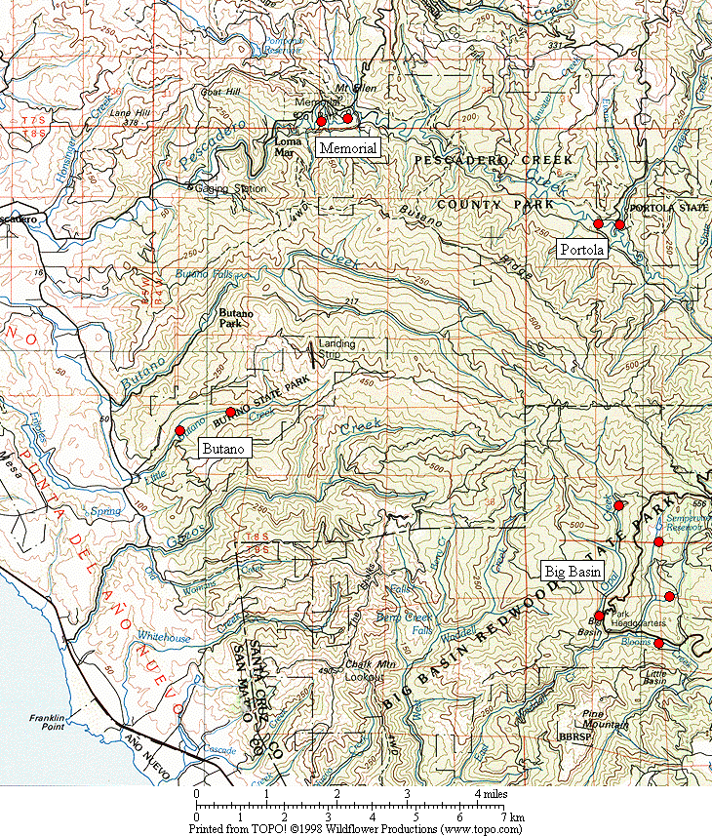

Figure 1. General location of the Marbled Murrelet monitoring stations in the four Santa Cruz Mountains parks.

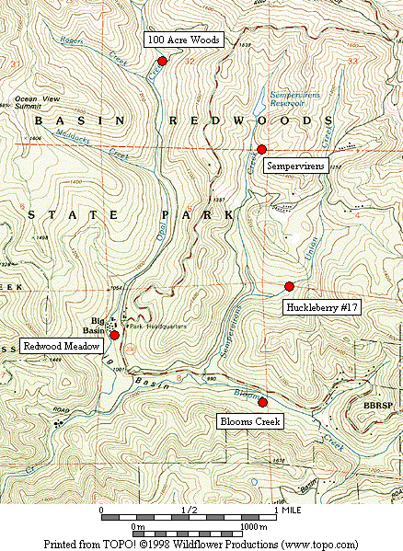

Figure 2. Location of Marbled Murrelet monitoring stations in Big Basin Redwoods State Park.

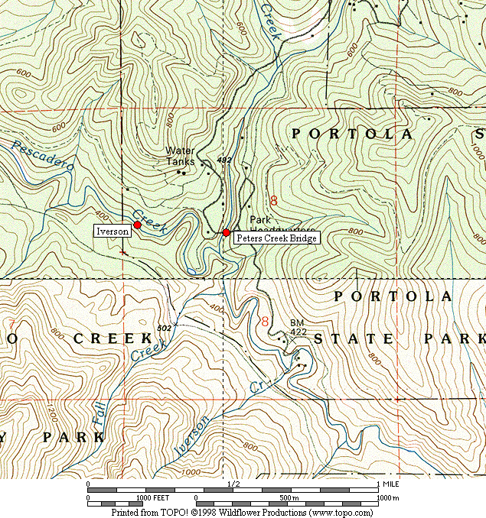

Figure 3. Location of Marbled Murrelet monitoring stations in Portola Redwoods State Park.

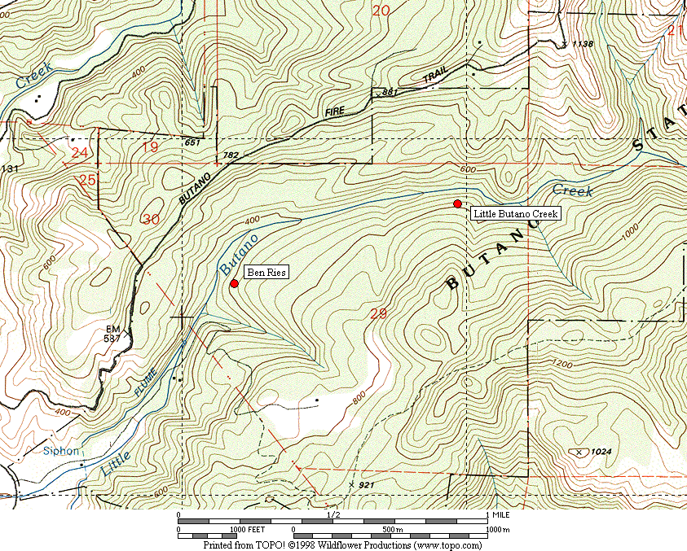

Figure 4. Location of Marbled Murrelet monitoring stations in Butano State Park.

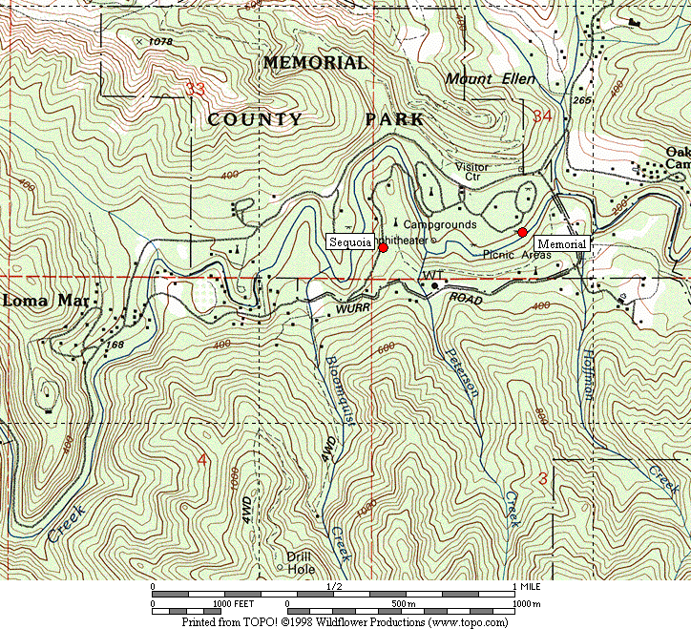

Figure 5. Location of Marbled Murrelet monitoring stations in San Mateo County Memorial Park.

Figure 6. Average murrelet activity on dawn surveys from all five Big Basin stations. (Note: no data from 1997, 1999 or 2000.)

Figure 7. Average annual murrelet activity at all five Big Basin stations, showing total detections (± s.d) with linear regression trend. (Note: no data from 1997, 1999 or 2000.)

A. “Redwood Meadow” B. “100 Acre Woods”

C. “Blooms Creek” D. “Huckleberry #17” (Note: no
detections were recorded in 2002)
E. “Sempervirens” (Note: no detections
were recorded in 2002 to 2005)

Figure 8. Annual activity levels (average total detections) at individual Big Basin monitoring stations from 1995 – 2005. (Note: no data for 1997, 1999 or 2000. See table 2 for standard deviations)
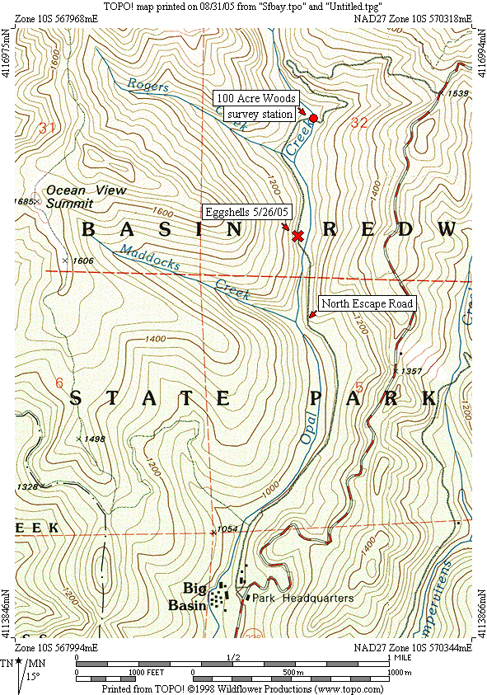

Figure 9. Location of Marbled Murrelet eggshell fragments found on North Escape Road at Big Basin on May 26, 2005.

Figure 10. Average detections from dawn surveys on three consecutive mornings in late June or early July at “Peters Creek Bridge,” Portola Redwoods State Park, 1992-2005. (Note: no data from 1996, 1997, 1999, or 2000.)

Figure 11. Linear regression on average detections from dawn surveys on three consecutive mornings at “Peters Creek Bridge” in Portola Redwoods State Park. (Note: no data from 1996, 1997, 1999, or 2000.)

Figure 12. Relative levels of Marbled Murrelet activity at each park in 2003 to 2005 using total detections.

Figure 13. Relative levels of Marbled Murrelet activity at each park in 2003 to 2004 using detections with occupied site behavior.

A. “Peters Creek Bridge”, Portola B. “Iverson”, Portola C. “Ben Ries”, Butano

D. “Little Butano Creek”, Butano E. “Memorial”, Memorial F. “Sequoia”, Memorial

Figure 14. Annual activity levels (average total detections) at individual monitoring stations from 2003-2005 at Portola, Butano and Memorial parks. (Note: scales for the y-axis vary; see table 2 for standard deviations)

32

- Steller’s Jay

- Common Raven

Figure 15. Average number of Steller’s Jays (A) and Common Ravens (B) per station in each park, 2001-2005. (Notes: Data from dawn murrelet surveys, using maximum count per year for each station. Jay numbers from 10-minute point counts, raven numbers from 2-hour surveys. Only Big Basin stations were surveyed in 2001-2002).

333

Figure 16. Average detections for all parks combined in 2003-2005.
Appendix 1. Bird species detected and point count maxima from 2005 dawn Marbled Murrelet surveys. (See footnote for key to station codes.)¹

Big Basin Portola Butano Memorial

Species RM BC HU OA SP PC IV BR LB ME SQ

Wood Duck – – – – – – X – – – –
Mallard – – – – X – X – – X
Common Merganser – – – – – X – – X X X
Great Blue Heron – X – – – – – – – – –
Sharp-shinned Hawk – – – – X X – 1 – – 2
Cooper’s Hawk – 1 1 – 1 – – – – – 1

Red-shouldered Hawk X – – X 1 1 2 X – 2 2
Peregrine Falcon X – – – – X – – – – 4
Marbled Murrelet ³ 4 X 1 3 – 8 1 4 5 X 7
Band-tailed Pigeon 3 3 4 2 2 2 1 4 4 2 5
Mourning Dove – 1 – – – – – – – – –
Western Screech-Owl – – – – X – X – – – –

Northern Pygmy-Owl – 1 – – – – – 1 – – –
Vaux’s Swift 4 – 2 – X – 1 – – – –
Allen’s Hummingbird 1 – – – – X X – 1 – 1
Belted Kingfisher – – – – – 1 – – – X –
Acorn Woodpecker 16 21 19 – 6 2 – 3 – 4 6
Hairy Woodpecker – 4 – X 1 2 2 X 2 1 1

Appendix 1, continued

Big Basin Portola Butano Memorial

Species RM BC HU OA SP PC IV BR LB ME SQ

Northern Flicker X 2 2 X 1 1 X X – – 1
Pileated Woodpecker 2 3 3 1 3 1 – 1 2 1 2
Pacific-slope Flycatcher 1 1 1 4 4 4 3 2 4 4 3
Violet-green Swallow – – – – – 16 4 1 1 X 1
Steller’s Jay 6 8 17 2 4 6 3 11 5 10 29
Common Raven 4 1 3 X 2 X – 1 (X)⁴ 2 5

Chestnut-backed Chickadee 4 5 5 2 4 4 4 3 2 4 5
Pygmy Nuthatch 5 12 5 2 4 4 7 4 1 2 7
Brown Creeper 3 3 4 2 3 3 3 3 1 3 2
Winter Wren 2 2 2 4 3 3 3 4 3 3 2
American Dipper – – – – – X – – – 1 –
Golden-crowned Kinglet 1 2 2 2 1 X 1 2 1 1 2

Hermit Thrush 2 6 3 3 2 2 1 1 2 1 1
Swainson’s Thrush 3 – – – – 1 1 2 2 –
American Robin 6 3 1 3 1 1 1 2 2 3 4
Varied Thrush – – – – – – – X – – –
Wrentit 3 – 1 – – – 2 – 1 – –
Wilson’s Warbler 1 1 2 1 1 2 2 4 4 2 –

Appendix 1, continued

Big Basin Portola Butano Memorial

Species RM BC HU OA SP PC IV BR LB ME SQ

Spotted Towhee 1 3 3 – – X X – – – –
Black-headed Grosbeak – – – – 1 – – – – 1 –
Dark-eyed Junco 4 – 4 2 2 2 X 1 – 3 1
Purple Finch 2 2 1 – 1 – X 1 X 1 X
Red Crossbill – – – – – – 2 – – –
Pine Siskin – – – – – – – X X X 1

1. Station codes: RM (Redwood Meadow), BC (Blooms Creek), HU (Huckleberry #17), OA (100 Acre Woods), SP (Sempervirens), PC (Peters Creek
Bridge), IV (Iverson Trail), BR (Ben Ries), LB (Little Butano Creek), ME (Memorial), SQ (Sequoia).
2. “X” denotes a species detected during a 2-hour survey, but not detected during any point count.
3. Number given for Marbled Murrelet is the best estimate from one or more detections during a point count.
4. Common Raven was recorded at Little Butano Creek station within 10 minutes of the end of one of the 2-hour dawn surveys.
Appendix 2. Comprehensive Summary of Dawn Marbled Murrelet Surveys at Redwood Meadow / Park Headquarters Area in Big Basin Redwoods State Park 1991-2005.

In addition to the 32 dawn surveys conducted at Redwood Meadow specifically for the California Dept. of Fish and Game (1995-2002) and the COSTC (2003-2005), Suddjian conducted 135 additional surveys from 1991-2005 at Redwood Meadow and the adjacent parking lot at Park Headquarters, for a total of 167 dawn surveys conducted there over the 15 year period (84% by Suddjian). In 2005 Suddjian conducted 13 additional surveys at the Redwood Meadow / Park Headquarters parking lot area from April 15 to July 24, beyond the three called for by COSTC contract, for 16 total surveys in 2005. An average of 11.1 dawn surveys (range 6-18 surveys) have been conducted annually, with 16-18 per year since 2002 (Figure 2-1).

The meadow and parking lot are 70 meters apart, and surveys in both spots sample largely the same activity (D. Suddjian pers. obs.). Auditory and some visual detections overlap broadly between the two stations. Thus, survey results from these adjacent spots are combined here to provide a long-term trend in murrelet activity in the park headquarters area. Additionally, the surveys span April to July, and so sample a broader portion of the murrelet nesting season than the current COSTC monitoring scheme.

Murrelet activity remained very low at Redwood Meadow / Park Headquarters in 2005 compared to activity in the early 1990s (Figures 2-2 and 2-3), with a highly significant declining trend evident for total detections (r² = 0.942, P <0.0001) and those with occupied site behavior (r² = 0.903, P <0.0001). Activity levels in 2005 remained at a continued low ebb that was first approached in 2002. However, even at a low ebb, activity has actually continued to decline over 2002-2005 (Figure 2-4). Annual medians, maxima, and minima have exhibited the same pattern, with the median values quite close to the minima since 2001 (Figure 2-5). Maxima have varied widely, but show the same declining trend over the 15-year period and have dropped annually since 2001 (Figure 2-5). Average total detections have declined annually in each of the four months from April to July (Figure 2-6). The murrelet’s typical seasonal peak expected in July has not occurred since 2001 (Figure 2-6).

Figure 2-1. Number of dawn surveys conducted annually at the Redwood
Meadow / Park Headquarters area in Big Basin from 1991-2005.

Figure 2-2. Average number of detections (± s.d) on dawn surveys at Redwood
Meadow / Park Headquarters, 1991-2005. (Note: see Figure 2-1 for annual sample
sizes. Surveys occurred between April 5 and July 31 each year.)

Figure 2-3. Average number of occupied behavior detections (± s.d) on dawn
surveys at Redwood Meadow / Park Headquarters, 1991-2005. (Note: see Figure
2-1 for annual sample sizes. Surveys occurred between April 5 and July 31 each year.)

Figure 2-4. Average number of detections on dawn surveys at Redwood
Meadow / Park Headquarters for 1998-2005 (Note: see Figures 2-2 and 2-3 standard deviations.)

Figure 2-5. Annual median, maximum and minimum total detections on dawn
surveys at Redwood Meadow / Park Headquarters in Big Basin, 1991-2005.

Figure 2-6. Monthly average number of detections on dawn surveys at Redwood Meadow / Park Headquarters in Big Basin, 1991-2005.

Appendix 3. Summary of Marbled Murrelet Detections During Coverage of a Breeding Bird Survey in Big Basin Redwoods State Park, 1992-2005.

The “Pescadero, CA” route (#14-319) is part of the USGS’s Breeding Bird Survey (BBS). The route begins in Big Basin just west of Blooms Creek Campground, and proceeds (via Gazos Creek Road, Cloverdale Road, and Pescadero Road) for 24.5 miles to San Mateo County Memorial Park. Birds are surveyed for three minutes at stops located every 0.5 mile. The route passes through various areas of suitable Marbled Murrelet habitat, but over this route’s history murrelets were only detected at the first 10 stops (Figure 3-1); the remaining areas of suitable habitat are not surveyed until after flight activity has ceased for the morning.

Suddjian initiated the “Pescadero, CA” BBS route in 1992, and has sampled it in most years since then. Each survey has occurred between May 29 and June 1. Official results for 1992-1997, and 2001-2005 are available at <http://www.pwrc.usgs.gov/bbs/>. The route could not be covered in its entirety during 1998-2000 due to road washouts and problems with access through a gate along Gazos Creek Road. But in all years except 2000 Suddjian at least surveyed the beginning portion of the route in Big Basin, including all the stops where murrelet activity has been recorded (Figure 3-1).

While the BBS method is not specifically designed for monitoring murrelets at forest sites, it does provide a repeated measure of murrelet activity, and coverage for the BBS at Big Basin was contemporaneous with the other monitoring efforts presented in this report. The first three stops at the very beginning of the route (Figure 3-1) are located in the East Waddell / Opal Creek watersheds in areas that through the early 1990s had very high levels of activity.

Murrelet activity recorded on the “Pescadero, CA” BBS route exhibited a pattern of decline from 1992 – 2005 that closely paralleled the decline recorded by the other Big Basin monitoring efforts (see Figure 7 and Appendix 2). Three related measures – (1) total detections, (2) total estimated individuals, and (3) the number of stops where murrelets were recorded – all showed the same pattern. The number of detections showed a highly significant declining trend (r² = 0.704, P 0.0002). No murrelets were detected at any of the stops in 2005, the first time the species has been missed since the route was initiatied.

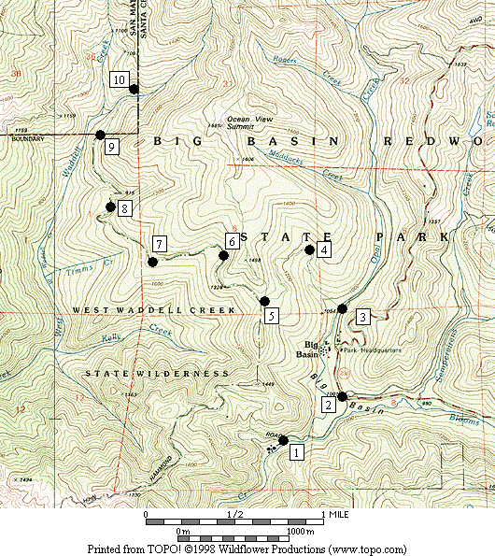

Figure 3-1. Stops on the Breeding Bird Survey route “Pescadero, CA” (#14-319) where Marbled Murrelets were detected on surveys in 1992-2005.

Figure 3-2. Marbled Murrelet activity recorded within Big Basin Redwoods State Park on the "Pescadero, CA” Breeding Bird Survey route in 1992 to 2005. (Note: No data for 2000.)

